# Project Design Phase 2TechnologyStack(Architecture&Stack)

|  |  |
| --- | --- |
| TeamID | PNT2022TMID51290 |
| ProjectName | Project - IoT Based Smart Crop Protection System forAgriculture |

**TEAMLEAD:**

* Iswariya A

# TEAM MEMBERS:

# Jusmitha J S

# Ebsiba L C

# Roshni P S

TechnicalArchitecture:

Thearchitecturaldiagramofthemodelisasbelowand theTechnologyusedisshownintable1&table2

**Reference:**https://smartinternz.com/guided-project/iot-based-smart-agriculture

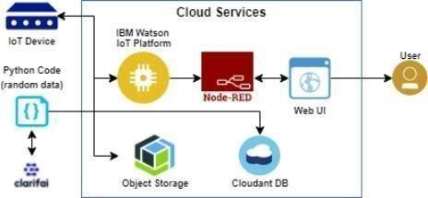

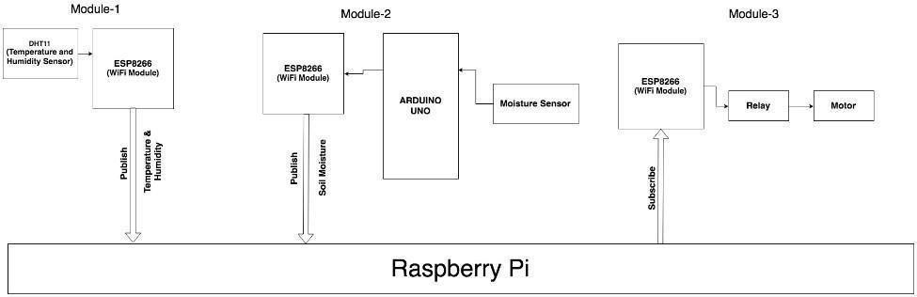

# FIG.1.BLOCKDIAGRAM

Table-1:Components&Technologies:

|  |  |  |  |
| --- | --- | --- | --- |
| **S.No** | **Component** | **Description** | **Technology** |
| 1. | UserInterface | Howuserinteractswithapplicatione.g.,MobileApplication | HTML,CSS,JavaScript/AngularJS/Node Red. |
| 2. | ApplicationLogic-1 | Logicfora processin theapplication | Java/Python |

|  |  |  |  |
| --- | --- | --- | --- |
| 3. | ApplicationLogic-2 | Logicfora processin theapplication | IBMWatson STTservice |
| 4. | ApplicationLogic-3 | Logicfora processin theapplication | IBMWatsonAssistant |
| 5. | Database | DataType,Configurationsetc. | MySQL,NoSQL,etc. |
| 6. | CloudDatabase | DatabaseServiceonCloud | IBMDB2. |
| 7. | FileStorage | Filestoragerequirements | IBMBlockStorageorOtherStorageServiceor LocalFilesystem |
| 8. | ExternalAPI-1 | PurposeofExternalAPIusedintheapplication | IBMWeatherAPI,etc. |
| 9. | IoT Model | Purpose of IoT Model is for integrating the sensorswith auser interface. | IBMIoTPlatform |
| 10. | Infrastructure(Server/Cloud) | ApplicationDeploymentonLocalSystem/CloudLocalServer Configuration:  CloudServerConfiguration: | Local,Cloud Foundry,Kubernetes,etc. |

References:<https://smartinternz.com/guided-project/iot-based-smart-agriculture>[https://www.computerweekly.com/news/252504285/How-IoT-and-machine](https://www.computerweekly.com/news/252504285/How-IoT-and-machine-learning-are-automating-agriculture)

[learning-are-automating-agricultu](https://www.computerweekly.com/news/252504285/How-IoT-and-machine-learning-are-automating-agriculture)[re](https://components.omron.com/us-en/solutions/iot) [https://compon](https://components.omron.com/us-en/solutions/iot) [en](https://components.omron.com/us-en/solutions/iot)ts.omron.com/usen/[solutions/iot](https://components.omron.com/us-en/solutions/iot)